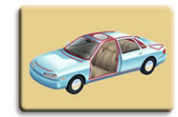
  NexPrene TPEs
  Automotive OEM Approvals

Several grades of NexPrene® TPEs, in both the 1000 series and 9000 series, have been approved to OEM specifications by the US Big Three carmakers. For a current list of the materials approved by Chrysler, Ford, or General Motors, click on the appropriate image below. Note that in some cases, a specific version of the listed grade (such as a black, natural, or UV-stabilized formulation) may be the approved material.
